INSTRUCTIONS FOR THOSE SUBMITTING PRE-RECORDED PRESENTATIONS
Note: If you were invited to submit a pre-recorded presentation, the Foundation sent you these instructions by email. If you would like the original email re-sent to you, send your request to symposium@beckman-foundation.org.

Following are instructions to assist you with preparing your pre-recorded presentation:
- Create your slideshow presentation using PowerPoint. Your slide aspect ratio can be set to standard or widescreen, and a 28-pt. font is recommended so that your audience can read slides easily.
- Where possible, try to use GIF files in place of embedded video. Neither are required.
- If you would like to use the Arnold and Mabel Beckman Foundation logo in your presentation, please see below for JPEG and PNG versions.
- Record your presentation using Zoom. Both the speaker and the slides should be visible throughout the presentation. Speaker attire should be business or business casual, with front lighting on the speaker (no back or side lighting, please).
- Save your Zoom recording as a MP4 file and use the file naming convention shown here (omit brackets): [Firstname]_[Lastname]_BeckmanSymposium_MP4
- Include a separate PDF of your slides and use the file naming convention shown here (omit brackets): [Firstname]_[Lastname]_BeckmanSymposium_PDF
- Please review your MP4 recording for audio/visual quality.
- If you are satisfied with your recorded presentation, submit your MP4 and PDF files as a Dropbox folder link (do not require password/sign-in) to symposium@beckman-foundation.org no later than July 17 (firm).

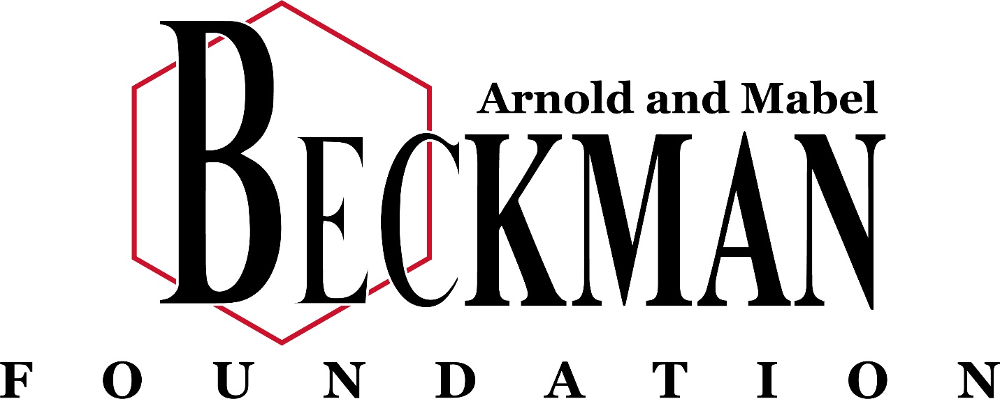

JPEG

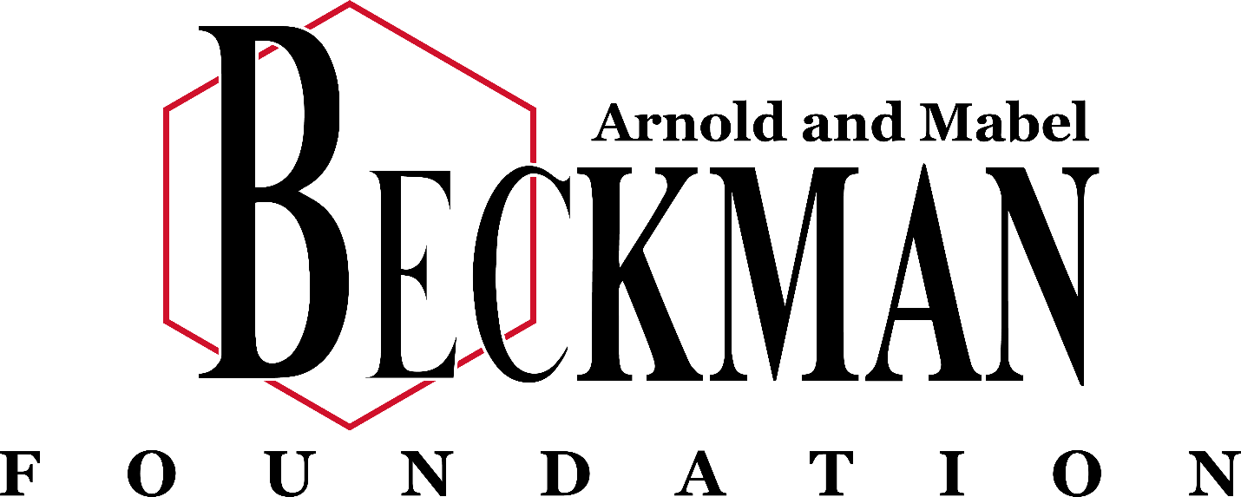

PNG

